**1. Summary of the aims and objectives of the project**

The university manually keeps track of the number of hours the students had worked and to proceed payment based on the hours worked. The timesheets are currently manually filled by the students and submitted to the assigned teachers(staff) for verification. Once the timesheet has been verified, it is submitted to the university for payment manually.

In this manual process, there are mainly three issues:

1. It is time consuming when submitting a timesheet as each student have to go to the teachers first and then to the university.

2. Each student have to fill one timesheet every month for the particular module they have enrolled with, and this is inconvenient as they have to print the timesheet before submitting it. If a student is enrolled in more than one module, they will have to fill more than one timesheet, and this will cause extra paper work for them.

3. The timesheet form structure is complex and crammed as some questions do not have to be answered.

Due to these limitations in the manual process, a web-based system is proposed. The purpose of the research is to develop and evaluate a web-based system in which the submission and verification of the timesheet will be performed through this system. The verified timesheets will be submitted to the university via the website for payment.

**2. Summary of any background research that you have done**

While researching for the project, I found a few articles and research papers with the same objective as my project. The objective was to develop a web-based timesheet management system which is reliable and efficient. After reading through the articles, I got some ideas that I can implement in the system such as timesheet reminder, a record of all the timesheets submitted and design of the system. They mentioned frameworks/technologies that they are using to implement the timesheet management system. These technologies used in the different articles helped me to create a list of options that I can use for my project. After that, I started comparing the different options of technologies, and I choose those that are the most suitable for the front-end, back-end and database of the project.

**3.** **Main features of the product / application / ‘solution’**

**Student**

1. Login

2. Submit Timesheet

3. View Timesheet Records

4. View Timesheet Statistics

5. View Timesheet Deadline

**Teacher**

1. Login

2. Verify Timesheet

3. View Timesheet Records

4. View Timesheet Statistics

5. View Timesheet Deadline

**Admin**

1. Login

2. View Timesheet Records

3. Set Timesheet Deadline

4. Set Timesheet Reminder

5. Set Access

6. Exporting Timesheet

**4. Summary of progress to date**

To complete the requirement documentation, the plan was to use the requirements that are present in the project description and gather more requirements from users such as students and teachers. After doing some research, the plan was changed as currently the timesheet system is manual, and it will be difficult to ask questions from the users. Based on this, a new plan was derived.

The order in which the documents were completed are as following:

1. Requirement documentation

2. User story documentation

3. Student and Teacher Wireframes - Made multiple versions for the different features present in the web-based system.

4. Student and Teacher Questions - This is based on the wireframes.

5. Distribute the questions to ask the users which version they prefer and any other suggestions. Based on the feedback the relevant documents were updated.

6. Product backlog

7. Sprint backlog

Currently I am setting up the following technologies to implement the timesheet system:

1. Front-end = Vue.js

2. Back-end = Node.js

3. Database = MongoDB

**5. Personal Reflection**

When I initially started working on the requirement documentation, I had only five requirements and each of them had a short description. I struggled on this document for about a few weeks as I did not know how to add more requirements and description as I was finding the scope of the project limited. After some research and discussions with my project advisor, I understood the scope of the project. Based on the understanding I manged to complete the requirement documentation and other documents relevant to the project. Apart from that, I prepared the wireframe questions by the middle of December. However, due to the upcoming holidays, it did not get distributed until the middle of January. Overall, I am happy with my progress despite the difficulties and delay I faced during the last few months.

**6. Summary of the plans for the remainder of the project**

Based on the Gantt chart in Figure 1, in February, I will be coding the key features for student and teacher timesheet management system based on the product and sprint backlog. While in March, I will be coding the key features for admin timesheet management system based on the product and sprint backlog. In April, I will be testing the code and completing the necessary documentation for the project. The project’s milestones will be the submission date and sprint review, which will take place with my project supervisor to review the status of the project.

**7. References**

1.<http://csus-dspace.calstate.edu/handle/10211.3/214829>

2.<https://www.tandfonline.com/doi/abs/10.1080/15228959.2020.1806178>

3.<http://ijpttjournal.org/volume-9/IJPTT-V9P404.pdf>

4.Template - <https://www.smartsheet.com/agile-project-management-excel-templates>

5.Template - <https://online.officetimeline.com/>

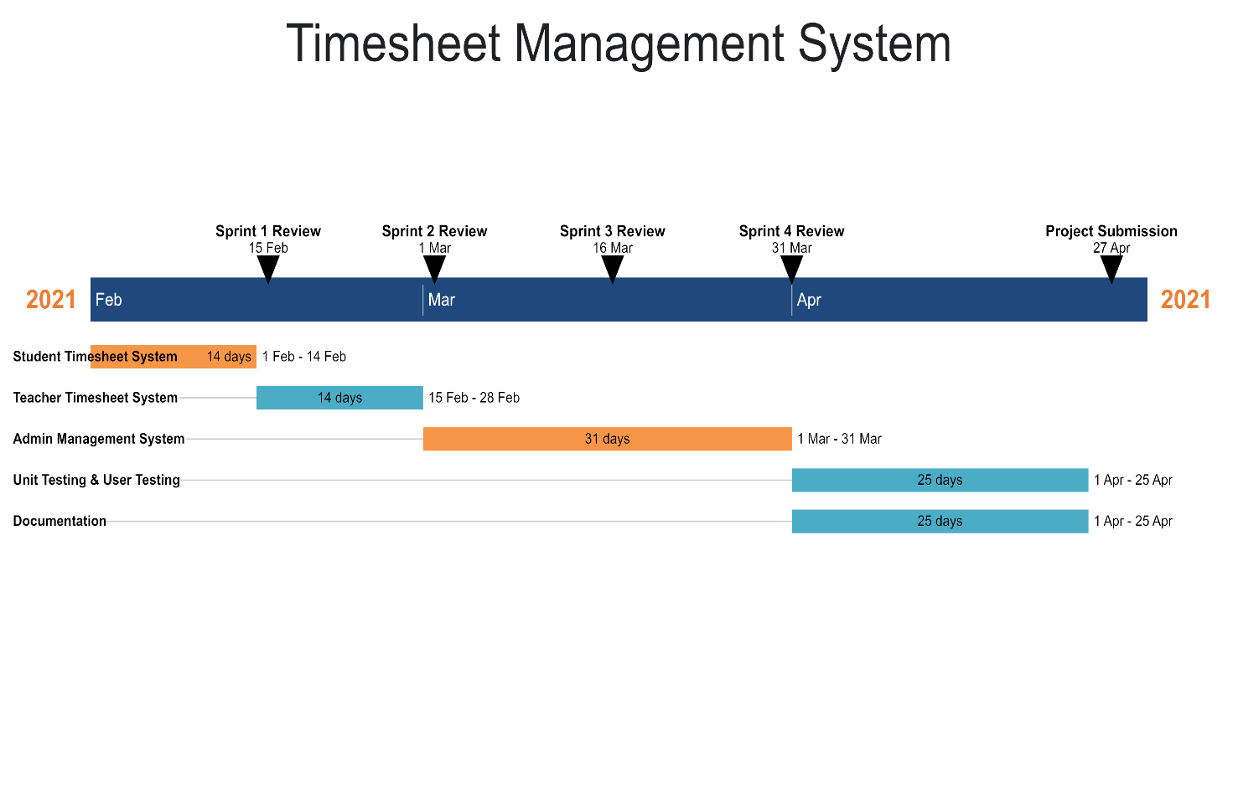

**Figure 1 - Gantt Chart**